Documentation

Main Class

Get starting balance

Get annual interest rate

Get the number of months that have passed

Do until month count = number of months passed

Get Deposit

Get Withdrawal

Display current months interest

Display ending balance from Savings Account Class

Display total deposits from Savings Account Class

Display total withdrawals from Savings Account Class

Display total interest from Savings Account Class

Savings Account Class

Savings Account

Balance

Withdrawal

Balance = Balance – withdrawl

Accum Withdrawal = Accum Withdrawal + Withdrawal

Deposit

Balance = Balance + Deposit

Accum Deposit = Accum Deposit + Deposit

Monthly Interest

Accum Interest = Accum Interest + Balance \* (Annual Int Rate / 12)

Balance = Balance + Balance \* (Annual Int Rate / 12)

Set Balance

Set Annual Int Rate

Return Balance

Return Annual Int Rate

Return Monthly Interest

Balance \* (Annual Int Rate / 12)

Return Accumulated Interest

Return Accumulated Deposits

Return Accumulated Withdrawals

Compile Screenshot

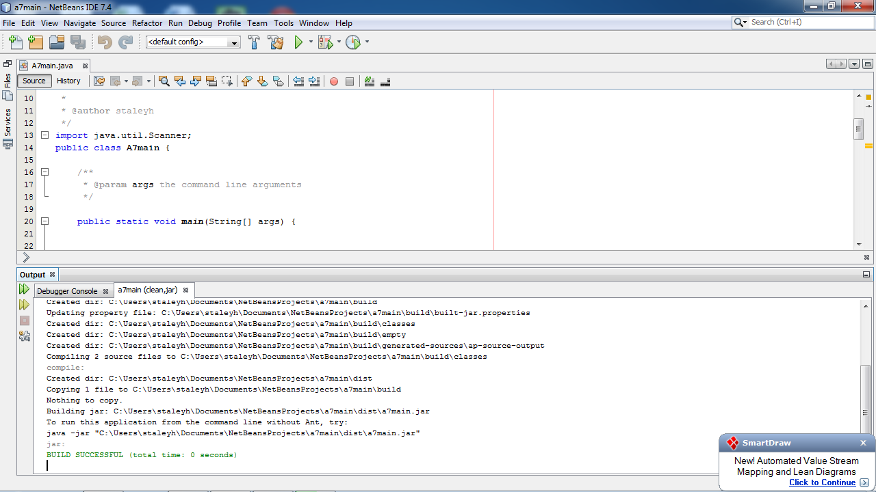Run Screenshot

